

|  |  |  |  |  |  |
| --- | --- | --- | --- | --- | --- |
| **NAME** |  | | | | |
| **SUBJECT** | **TECHNICAL DRAWING 3 (PRACTICAL)** | **CLASS** | **SS 1** | **DURATION** | **1 ½ HOURS** |

INSTRUCTION: Answer three questions in this paper.

(60MARKS)

1. The elevation of a truncated cylinder is shown below?

i. Draw full size the given view

ii. Produce the pattern development. NECO 2021, Q.4 (20 marks)

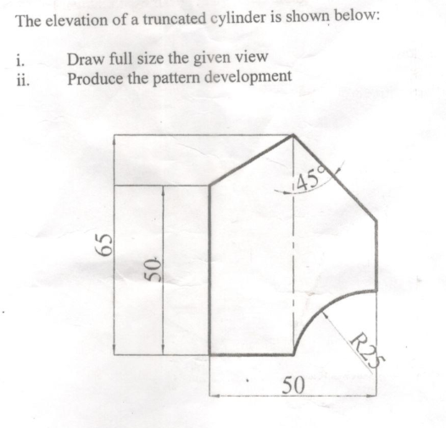

2.   The figure below shows the two views of equilateral pryramid cut by plane XX

(a) the given view (5 marks)

(b) complete elevation and the plan (5 marks)

(c) the surface development of the pyramid using the small side as seam. (10 marks)

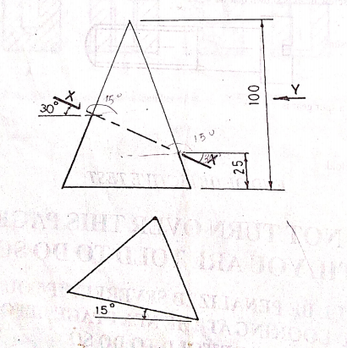

3. The sketch in figure below shows a three piece cylinder pipe of diameter 50

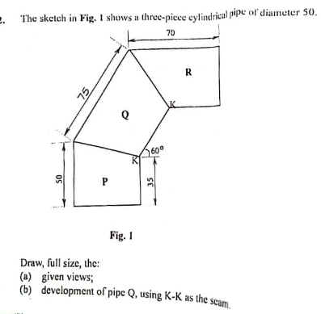

Draw full size the:

(a) Given view (5 marks)

(b) development of pipe Q using K-K as the seam (15 marks)

**WAEC, Technical Drawing Paper 1, May/June 2024. Q. 2**

4. A cylindrical bar, 50 diameter, rolls up a ramp having a slope of 300 to the horizontal without slipping as shown above.

(a) Construct the path of the point P on the rim of the bar as it makes one complete revolution up the ramp. (18 marks)

(b) Name the curve obtained (2 marks)

Technical Drawing 2, Nov/Dec 2015, Q.2